SERVIDOR DNS - UBUNTU SERVER (BIND9)
Zona: aulalinux.local | Rede: Classe C - 192.168.0.0/24
=========================================================
------------------------------------------------------------
1. ATUALIZAÇÃO E INSTALAÇÃO DOS PACOTES
------------------------------------------------------------

sudo apt update
sudo apt upgrade -y
sudo apt install bind9 bind9utils bind9-doc dnsutils -y

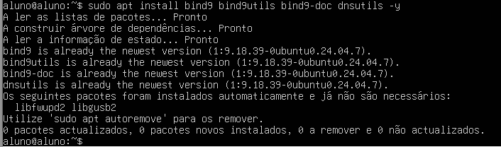

------------------------------------------------------------
2. CONFIGURAR /etc/bind/named.conf.options
------------------------------------------------------------

sudo nano /etc/bind/named.conf.options

acl internal-network {
192.168.0.0/24;
};
options {
directory "/var/cache/bind";
allow-query { localhost; internal-network; };
allow-transfer { localhost; };
forwarders {
10.107.132.4;
};
recursion yes;
dnssec-validation no;
# listen-on-v6 { any; };
};
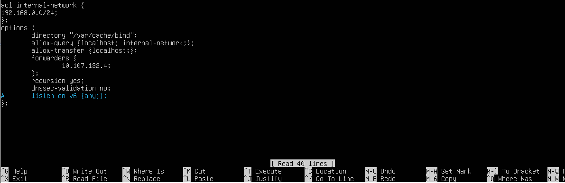

------------------------------------------------------------
3. CONFIGURAR /etc/bind/named.conf.local
------------------------------------------------------------

sudo nano /etc/bind/named.conf.local
zone "aluno.local" IN {
type master;
file "/etc/bind/forward.aluno.local";
allow-update { none; };
};
zone "0.168.192.in-addr.arpa" IN {
type master;
file "/etc/bind/reverse.aluno.local";
allow-update { none; };
};

